#45 - Nephi

Spanish Addresses

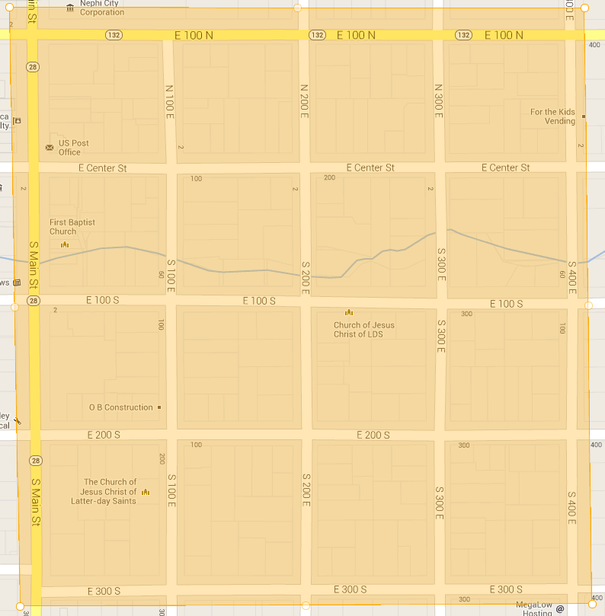

Do Not Calls

Please return to the Delta English
Congregation (435)864-7999

